**How to Submit: Demonstration in Class only (check the deadline from course agenda and policies, late penalty 100%). Answers/Solutions could be in clear hand written or in electronic format, Screenshots required for the zeus related work .**

In this lab, you will learn how to:

1. **Merge sets of 3NF Relations from each user view into one set of 3NF Relations for application**
2. **Retrieve information from a database by executing some basic SQL statements using the iSeries native interface (i.e. "Green Screen").**

PART A: Merge 3NF Relations

Step 1: Obtain 3NF relations for each user view (from Labs 4 and 5) for application:

1 CUSTOMER [ CustNo, CustName, CustStreet, CustCity, CustSt, CustZip, CustRep ]

2 PART [ PartNo, PartDescr, QtyOnHand, Class, Whse, Price]

3A CUSTOMER [ CustNo, CustName ]

3B CUSTORDER [ CustNo, OrderNo, OrderDate ]

4A ORDER [OrderNo, OrderDate, CustNo ]

4B ORDERDetail [OrderNo, PartNum, NumOrdered ]

4C PART [ PartNum, PartDescr, QuotedPrice]

5A CUSTORDER [ CustNum, OrderNum ]

5B ORDER [ OrderNum, Orderdate ]

5C CUST [CustNum, CustName, RepNo]

5D REP [RepNo, RepName]

**Step 2: Use consistent name for same attribute in each relation** (eg for attributes PartNo, PartNum representing a Part Number use a consistent name of PartNo; for attributes CustRep and RepNo representing a Sales Representative’s Number use RepNo; for attributes CustNo and CustNum representing a Customer Number use CustNo; and for attributes Price and QuotedPrice representing the Price of a part use Price).

1 CUSTOMER [ CustNo, CustName, CustStreet, CustCity, CustSt, CustZip, **RepNo** ]

2 PART [ PartNo, PartDescr, QtyOnHand, Class, Whse, Price]

3A CUSTOMER [ CustNo, CustName ]

3B CUSTORDER [ CustNo, OrderNo, OrderDate ]

4A ORDER [OrderNo, OrderDate, CustNo ]

4B ORDERDetail [OrderNo, **PartNo**, NumOrdered ]

4C PART [ **PartNo**, PartDescr, **Price**]

5A CUSTORDER [ **CustNo, OrderNo** ]

5B ORDER [ **OrderNo**, Orderdate ]

5C CUST [**CustNo**, CustName, RepNo]

5D REP [RepNo, RepName]

**Step 3:** Examine Primary Key of each relation with composite Primary Key to determine if all parts should be part of Primary Key:

3B CUSTORDER [ CustNo, OrderNo, OrderDate ] – CustNo is not required to be part of PK because OrderNo uniquely identifies an order. If Composite Primary Key was left as is then unique values could include (OrderNo 1001, CustNo 2) and (OrderNo 1001, CustNo 5) which is incorrect for application SINCE Customers 2 and 5 would each have an order numbered 1001!

🡪 3B CUSTORDER [OrderNo, CustNo, OrderDate]

5A CUSTORDER [ CustNo, OrderNo ] 🡪 CUSTORDER [**OrderNo, CustNo** ]

**Step 4:** Use consistent name for relations with same attributes in Primary Key:

1 CUSTOMER [ CustNo, CustName, CustStreet, CustCity, CustSt, CustZip, RepNo ]

2 PART [ PartNo, PartDescr, QtyOnHand, Class, Whse, Price]

3A CUSTOMER [ CustNo, CustName ]

3B **ORDER** [OrderNo, OrderDate, CustNo ]

4A ORDER [OrderNo, OrderDate, CustNo ]

4B ORDERDetail [OrderNo, PartNo, NumOrdered ]

4C PART [ PartNo, PartDescr, Price]

5A **ORDER** [OrderNo, CustNo ]

5B ORDER [ OrderNo, Orderdate ]

5C **CUSTOMER** [CustNo, CustName, RepNo]

5D REP [RepNo, RepName]

**Step 5:** Create one relation for relations having same attributes in Primary Key:

1,3A,5C CUSTOMER [ CustNo, CustName, CustStreet, CustCity, CustSt, CustZip, RepNo ]

2, 4C PART [ PartNo, PartDescr, QtyOnHand, Class, Whse, Price]

3B, 4A, 5A, 5B **ORDER** [OrderNo, OrderDate, CustNo ]

4B ORDERDetail [OrderNo, PartNo, NumOrdered ]

5D REP [RepNo, RepName]

**Step 6:** Resolve any new transitive dependencies, if any were created in Step 5 (None were in this example)

An example of this would occur with merging of the following relations:

CUSTOMER [ CustNo, CustName, CustStreet, CustCity, CustSt, CustZip, RepNo ]

CUSTOMER [CustNo, CustName, RepName ]

🡪 CUSTOMER [CustNo, CustName, CustStreet, CustCity, CustSt, CustZip, RepNo, RepName ]

which now has the transitive dependency of RepName (really determined by attribute RepNo) and would be resolved as:

CUSTOMER [CustNo, CustName, CustStreet, CustCity, CustSt, CustZip, RepNo]

REP [ RepNo, RepName ]

**Step 7:** Revise ERD as required with one entity for each relation and a relationship for each foreign key (an attribute in one relation that corresponds to the primary key of another relation)

**Step 8:** For each side of each relationship on the ERD determine whether the relationship is optional (0) or mandatory (1) and indicate on the ERD.

Now complete the exercise on the last page of this lab.

**PART B: Using the iSeries to enter SQL statements.**

<div class="MsoNormal"><![if !supportEmptyParas]><![endif]><o:p></o:p></div><div class="MsoNormal">**0.**     Open iSeries Navigator and start the Emulator as you did in Lab1 (right click Odin and select Display Emulator). Sign on and don't forget to TAB between fields!

Press Enter once you have seen the "Signon information". You must add the Premiere Collection to your library list by entering the following command at the command line:

**ADDLIBLE PREMIERE**

and press Enter key.

**1.** You should be within the SQL environment where the **title** of the screen is **"Enter SQL Statements"**.  If you are not at this screen, enter the command **STRSQL** on the command line and press Enter.  </div><div class="MsoNormal"></div>

**2.** Practice the following to get accustomed to the keyboard.<span style="mso-spacerun: yes"></span>:

**Try the up and down arrow keys**. <span style="mso-spacerun: yes"></span>They may or may not scroll up or down! **Press the Scroll Lock key and then try the up and down arrow keys.**<span style="mso-spacerun: yes"></span><o:p></o:p>

When the Scroll Lock key is on, the Page Up, Page Down and arrow keys do not work. It is possible to accidentally brush the Scroll Lock key and become frustrated with a set of keys that do not seem to work. <span style="mso-spacerun: yes"></span>Whether the keys were not working originally, or if you just locked them now:

**Make the keys work correctly by pressing Scroll Lock, if required, to turn Scroll Lock off.** <div class="MsoNormal"></div>  <div class="MsoNormal"><o:p></o:p></div><div class="MsoNormal" style="margin-left:.5in"><![if !supportEmptyParas]><![endif]><o:p></o:p></div>

**3.    Move the cursor up to the title where it says “Enter SQL Statements” and press the letter “w”.**<o:p></o:p> By doing this, you are trying to enter something in a protected area of the display. <span style="mso-spacerun: yes"></span>The system will display a message at the bottom of the screen on the message line and will freeze the keyboard.<span style="mso-spacerun: yes"></span>

When the keyboard is frozen a red **X** will also be displayed in the lower left-hand corner.

<![if !supportEmptyParas]><![endif]><o:p></o:p>**Press the ESC key to unfreeze the keyboard.**<o:p></o:p>

<![if !supportEmptyParas]><![endif]><o:p></o:p><span style='text-decoration:none;text-underline: none'>**Press the TAB key to advance to the next input capable field</span><span style='text-decoration:none;text-underline:none'>** - in this case where SQL statements are to be entered.<o:p></o:p></span> <div class="MsoNormal"><![if !supportEmptyParas]><![endif]><o:p></o:p></div><div class="MsoNormal">The text on your our screen should look similar to the one shown below.</div> <div class="MsoNormal"><![if !supportEmptyParas]><![endif]><o:p></o:p></div>

*Type SQL statement, press Enter.*<o:p></o:p>

*Current connection is to relational database S10AA67B*

*=== _____________________________________________________________________*<o:p></o:p> <![if !supportEmptyParas]><![endif]><o:p></o:p>

**4.** A very useful key is the **F4** (also known as the Prompt) key. <![if !supportEmptyParas]><![endif]><o:p></o:p>

**Press F4 to have the system list what is available in the interactive SQL environment.**

**<![if !supportEmptyParas]><![endif]><o:p></o:p><span style='text-decoration:none;text-underline:none'><o:p></o:p></span><div class="MsoNormal"><![if !supportEmptyParas]><![endif]><o:p></o:p></div><div class="MsoNormal">Use the Page Down key to see how many SQL statements are listed. Write the number: ____</div> <div class="MsoNormal"><![if !supportEmptyParas]><![endif]><o:p></o:p></div>**

**5.** At the bottom of the screen is a list of available function keys. Take a look at them now. <span style="mso-spacerun: yes"></span>On this platform, the common way to ***exit*** a process involves pressing <![if !supportEmptyParas]><![endif]><o:p></o:p>_________ and the common way to ***cancel*** a process involves pressing _____________. <span style="mso-spacerun: yes"></span>Sometimes these achieve the same result.

🡺 Exit or cancel now.

**6**.    Command prompting can be used when you are unsure of the syntax of a command. Command prompting can be invoked by entering the command name and pressing the **F4** key. The **SELECT** statement is used to retrieve data from a relational database.

Type SELECT and press F4. You should see a screen similar to the one shown below.

<div class="MsoNormal"><span style="mso-spacerun: yes"></span></div><div class="MsoNormal"><!--[if gte vml 1]><v:shape id="_x0000_i1026" type="#_x0000_t75"

style='width:423pt;height:307.5pt'>

<v:imagedata src="./lab1_files/image003.png" o:title=""/>

</v:shape><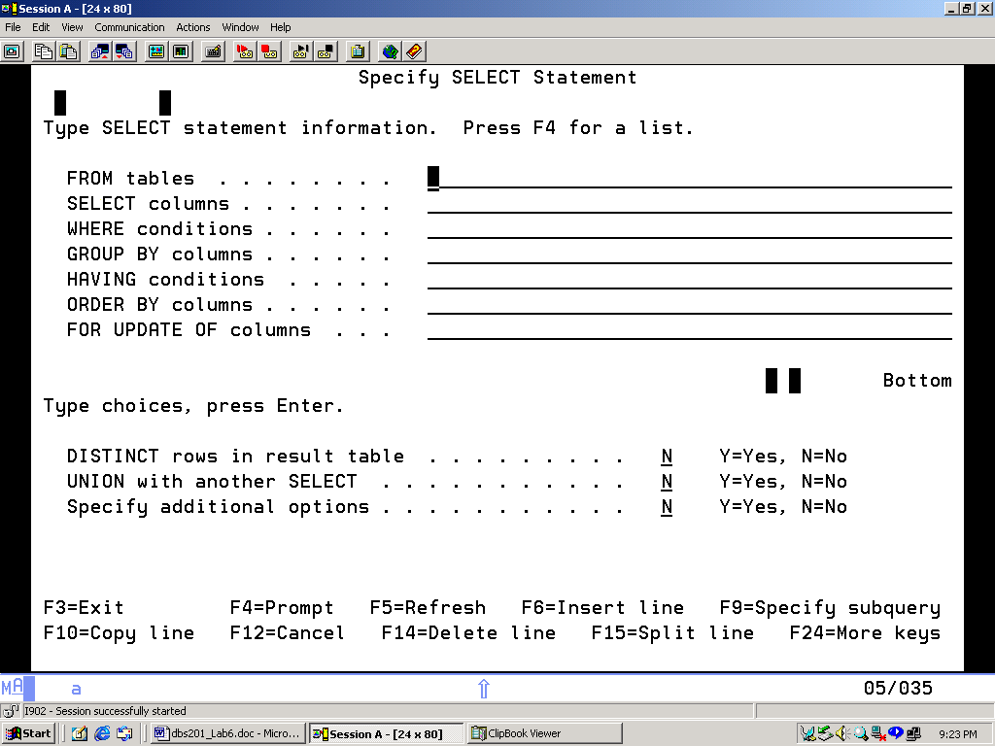<![endif]><span style="mso-spacerun: yes"></span></div><div class="MsoNormal"><![if !supportEmptyParas]><![endif]><o:p></o:p></div>

<![if !supportEmptyParas]><![endif]><o:p></o:p>

7. Place your cursor on the FROM tables clause and press the F4 key

A screen similar to the following should appear.

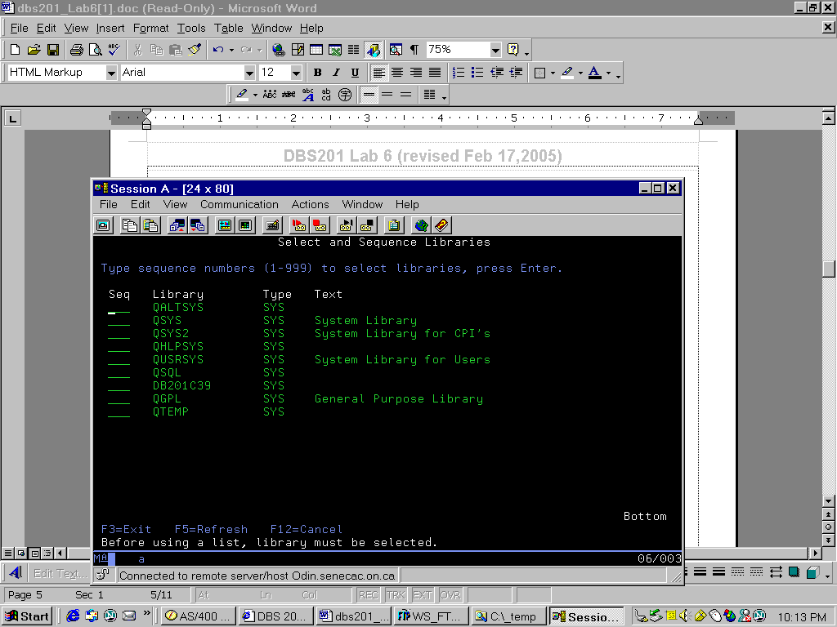

**Type a 1 beside the Collection that has the same name as your Userid (DC201*XXX*) and press Enter.** You should now see an error message at the bottom of the screen. <span style="mso-spacerun: yes"></span>What is the error message that appears at the bottom of the screen?

<![if !supportEmptyParas]><![endif]><o:p></o:p>________________________________________________________

<![if !supportEmptyParas]><![endif]><o:p></o:p>When an error occurs you can place the cursor on the statement and press the Help key. <span style="mso-spacerun: yes"></span>The Help key is the F1 key.<span style="mso-spacerun: yes"></span><o:p></o:p>

<![if !supportEmptyParas]><![endif]><o:p></o:p><![if !supportEmptyParas]><![endif]><o:p></o:p><![if !supportEmptyParas]><![endif]><o:p></o:p>**Put the cursor on the error message and press the F1 (Help) key to obtain more information about the error.**<span style="mso-spacerun: yes"></span><o:p></o:p> <![if !supportEmptyParas]><![endif]><o:p></o:p>There is some information about the cause of the error and ways to correct it. <span style="mso-spacerun: yes"></span><![if !supportEmptyParas]><![endif]><o:p></o:p><![if !supportEmptyParas]><![endif]><o:p></o:p>This information should allow you to correct the error. <span style="mso-spacerun: yes"></span>If you still do not know how to correct the error, you can press F10 to look at the job log that may contain additional helpful messages. An error occurred because the collection you created in a previous lab is empty.

**<![if !supportEmptyParas]><![endif]><o:p></o:p><span style='text-decoration:none;text-underline:none'>Press F10. <o:p></o:p></span>**<div class="MsoNormal"><![if !supportEmptyParas]><![endif]><o:p></o:p></div><div class="MsoNormal">After looking at the job log,</div> p<div class="MsoNormal"><![if !supportEmptyParas]><![endif]><o:p></o:p></div><span style='text-decoration:none;text-underline:none'>ress F3</span><span style='font-weight:normal;text-decoration:none;text-underline:none'> **twice** to exit back to the screen to enter SQL statements.</span><span style='text-decoration:none; text-underline:none'><o:p></o:p></span>

A database collection also called a library or a database schema called **PREMIERE** has been set up for all students to access.

Now try: **Type Select; Press F4; Press F4 again; <div class="MsoNormal"><![if !supportEmptyParas]><![endif]><o:p></o:p></div><div class="MsoNormal"><!--[if gte vml 1]><v:shape id="_x0000_i1027" type="#_x0000_t75"**

**style='width:306.75pt;height:222.75pt'>**

**<v:imagedata src="./lab1_files/image005.png" o:title=""/>**

**</v:shape><![endif]--><![if !vml]><![endif]><span style="mso-spacerun: yes"></span><o:p></o:p></div><div class="MsoNormal"><![if !supportEmptyParas]><![endif]><o:p></o:p></div>Type a 1 beside Premiere and press Enter**

<![if !supportEmptyParas]><![endif]><o:p></o:p>  
**8**.    Of the tables listed write the names of the five tables that have a type of TAB (short for TABLE):<span style="mso-spacerun: yes"></span> <![if !supportEmptyParas]><![endif]><o:p></o:p>

_____________________ _<span style='mso-tab-count:2'></span>_____________________ __<span style="mso-spacerun: yes"></span>____________________

<![if !supportEmptyParas]><![endif]><o:p></o:p>_____________________ _<span style='mso-tab-count:2'></span>_____________________<span style='mso-tab-count:2'></span>

**<![if !supportEmptyParas]><![endif]><o:p></o:p><![if !supportEmptyParas]><![endif]><o:p></o:p>99.** To choose the customer table:<span style="mso-spacerun: yes"></span> **<![if !supportEmptyParas]><![endif]><o:p></o:p>Type a 1 beside CUSTOMER and press Enter.**

<div class="MsoNormal"><![if !supportEmptyParas]><![endif]><o:p></o:p></div><div class="MsoNormal">You should now see: **<span style="mso-spacerun: yes"></span>From tables** . . . . . . **PREMIERE/CUSTOMER**<span style="mso-spacerun: yes"></span></div> <div class="MsoNormal"><![if !supportEmptyParas]><![endif]><o:p></o:p></div>

<![if !supportEmptyParas]><![endif]><o:p></o:p>**10.** Now that you have chosen a table to retrieve data from, you must now choose the columns you want to see. If you do not know the names of the columns in the customer table:

**<![if !supportEmptyParas]><![endif]><o:p></o:p>TAB to the Select Columns line and press F4.**

You may now choose the columns you wish to include in your report by placing a number beside each of the columns you desire to see. Indicate the <div class="MsoNormal"><![if !supportEmptyParas]><![endif]><o:p></o:p></div><div class="MsoNormal">columns by placing the numbers 10, 20, 30 … 100 (or by using any set of numbers in ascending order) beside each of the chosen columns.</div> <div class="MsoNormal"><![if !supportEmptyParas]><![endif]><o:p></o:p></div>

**Type 10 and press TAB, type 20 press TAB etc. <span style="mso-spacerun: yes"></span>Press Enter when all columns have been numbered.**

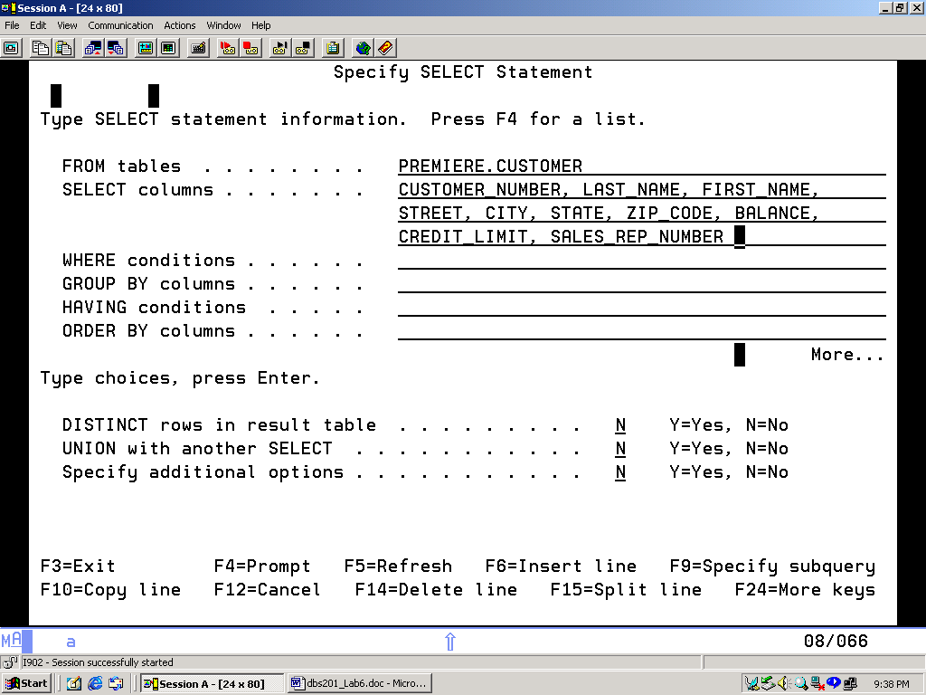<![if !supportEmptyParas]><![endif]><o:p></o:p>

<!--[if gte vml 1]><v:shape id="_x0000_i1028" type="#_x0000_t75"

style='width:324pt;height:235.5pt'>

<v:imagedata src="./lab1_files/image007.png" o:title=""/>

</v:shape><![endif]--><![if !vml]><![endif]><span style="mso-spacerun: yes"></span>

<![if !supportEmptyParas]><![endif]><o:p></o:p>**11.** The SELECT statement screen should look similar to the one shown above.

<![if !supportEmptyParas]><![endif]><o:p></o:p>**Press Enter key to run the SQL statement.**<o:p></o:p>

<![if !supportEmptyParas]><![endif]><o:p></o:p>You can’t see all the data for every column. <span style="mso-spacerun: yes"></span>You need to scroll to the right of the screen. <span style="mso-spacerun: yes"></span>At the bottom of the screen it says that the F20 key is used to scroll to the right. <span style="mso-spacerun: yes"></span>However there is no F20 key on the keyboard. <![if !supportEmptyParas]><![endif]><o:p></o:p>The function key mappings for F13 – F24 involve using the shift key and a function key. <span style="mso-spacerun: yes"></span>To get F13 you would press SHIFT + F1.

<span style="mso-spacerun: yes"></span>What keys should you press to scroll to the right? ___________________. Try it, and then press the appropriate key _____ to scroll back to the left.

<![if !supportEmptyParas]><![endif]><o:p></o:p>**Press Enter key** **to return to the initial SQL screen.**

<![if !supportEmptyParas]><![endif]><o:p></o:p>A history of all the SQL statements you have entered is maintained.<span style="mso-spacerun: yes"></span>

**12. <div class="MsoNormal"><![if !supportEmptyParas]><![endif]><o:p></o:p></div><span style='text-decoration:none;text-underline:none'>Move the cursor up to the previous complete Select statement and press F9**<o:p></o:p></span>.<![if !supportEmptyParas]> <![endif]><o:p></o:p>

<![if !supportEmptyParas]><![endif]><o:p></o:p><span style='text-decoration:none;text-underline:none'><o:p></o:p></span><div class="MsoNormal"><![if !supportEmptyParas]><![endif]><o:p></o:p></div><div class="MsoNormal">A useful key is the Field Exit key. On the keyboard the Field Exit key is provided by using the plus (+) symbol on the numeric keypad. <span style="mso-spacerun: yes"></span>Press F9 to retrieve your previous SQL command then use the Field Exit key to wipe out the three lines of SQL.</div> <div class="MsoNormal"><span style="mso-spacerun: yes"></span></div>

<span style='text-decoration:none;text-underline:none'>Press + key on the numeric keypad three times, then use the Tab key to get back to the top line.<o:p></o:p></span>

<div class="MsoNormal"><![if !supportEmptyParas]><![endif]><o:p></o:p></div><div class="MsoNormal" style="margin-left:24.0pt;text-indent:-21.0pt;mso-list:l0 level1 lfo1; tab-stops:list 24.0pt">**13.** You can enter a SQL statement directly without using the Prompt key.  For example:</div>

<div class="MsoNormal" style="margin-left:3.0pt"><![if !supportEmptyParas]><![endif]><o:p></o:p></div>**Type the following**: SELECT  *  FROM PREMIERE.SALESREP and **press the Enter key.  Notice that using the '*'  in SQL displays all the columns without having to specify them.** <div class="MsoNormal" style="margin-left:3.0pt"></div>

<![if !supportEmptyParas]><![endif]><o:p></o:p>**14.** Now you are to find out all the part descriptions in the Premiere Collection. You want to see these in order by the part description. What table in the Premiere database contains part descriptions (see step 7 for list of tables)<span style="mso-spacerun: yes"></span>: <![if !supportEmptyParas]><![endif]><o:p></o:p>___________________<span style='mso-tab-count:1'></span>

<![if !supportEmptyParas]><![endif]><o:p></o:p>**Type a statement similar to the one in #13** but now replace the SALESREP table with the name of the table that contains part descriptions.

**Press Enter** to run it. However t<![if !supportEmptyParas]><![endif]><o:p></o:p>he output is not in order by part description.

<span style="mso-spacerun: yes"></span>To sort output the ORDER BY clause is used. <![if !supportEmptyParas]><![endif]><o:p></o:p><span style="mso-spacerun: yes"></span>**Retrieve your previous command using F9 and prompt (F4**).  Place the cursor on the **Order By line and press the F4 key**. **Select the Part Description column to be used to sort the output and press the Enter key**.

Run the command to verify that the output is sorted by part description.

**Press Enter** to get back to the Enter SQL Statements screen. <div class="MsoNormal"></div>

**15**.      Run the previous command again, this time changing the sequence of the columns so that class is first and the list is sorted by class and part number.

**16**.      Suppose that you are only interested in certain data in a table, for example, only those Parts where Class is 'HW'. Retrieve the previous command and prompt. **Place your cursor on the Where conditions line and press F4**.  Enter a 1 beside Class and press Enter. Complete the command by entering = 'HW' (**Note: single quotes must be used with character data**). Press Enter to run the command.Other operators that may be used are **<, <=, =** (relational operators) and **!**, **AND**, **OR** (logical operators).

**17.** Using the F4, F1, F9, Tab and other keys and strategies you have learned to create the following queries. **For each query list the SQL statement created (SELECT …). DO NOT list the data results!**

Write the SQL statement used to list the last name, first name and credit limit of any customer with a credit limit greater than $1000:

_______________________________________________________________________________

<![if !supportEmptyParas]><![endif]><o:p></o:p>_______________________________________________________________________________

<![if !supportEmptyParas]><![endif]><o:p></o:p>_______________________________________________________________________________

Write the SQL statement used to list the all parts in warehouse 3 that have more than 100 units on hand (you will have to use an AND to join the 2 conditions). Sort the list by part number:

<![if !supportEmptyParas]><![endif]><o:p></o:p>_______________________________________________________________________________

<![if !supportEmptyParas]><![endif]><o:p></o:p>_______________________________________________________________________________

_______________________________________________________________________________

<![if !supportEmptyParas]><![endif]><o:p></o:p>_______________________________________________________________________________

<![if !supportEmptyParas]><![endif]><o:p></o:p>  **18**.  All of the output from your SQL statements has been going to the display screen. **To print one of these SQL reports,** you must access the Interactive SQL Session Services and change the session attributes:

**Press F13.  <span style="mso-spacerun: yes"></span><span style='mso-tab-count:2'></span>Select option 1**<o:p></o:p>

There are a number of session attributes that can be changed.

<![if !supportEmptyParas]><![endif]><o:p></o:p>a) You can change the statement processing:

<![if !supportEmptyParas]><![endif]><o:p></o:p>        *Run – syntax check, validity check, and run<span style='mso-tab-count:1'></span>*VLD – syntax check and validity check

        *SYN- syntax check only <span style='mso-tab-count:3'></span>(validity check would ensure the referred-to object exists)

<![if !supportEmptyParas]><![endif]><o:p></o:p>b) You can redirect the output from the screen to the printer or to a new database file.

<![if !supportEmptyParas]><![endif]><o:p></o:p>There are a total of 15 parameters that can be set. <span style="mso-spacerun: yes"></span>

<!--[if gte vml 1]><v:shape id="_x0000_i1029" type="#_x0000_t75"

style='width:396pt;height:288.75pt'>

<v:imagedata src="./lab1_files/image009.png" o:title=""/>

<![if !supportEmptyParas]><![endif]><o:p></o:p>**To change your session attributes so that the output from the SQL query is sent to the printer, change the Select Output option to 2 (for printer).**<o:p></o:p>

<![if !supportEmptyParas]><![endif]><o:p></o:p><![if !supportEmptyParas]><![endif]><o:p></o:p>Re-run the last 2 statements from section 16.  There are no reports on the screen because printer output was created.

**After you have run the statements, go back and redirect the output so that output will now be displayed on the screen**. <span style="mso-spacerun: yes"></span>If you do not reset this, the next time you log in and run a query you may be puzzled because no output will be displayed on the screen.

<![if !supportEmptyParas]><![endif]><o:p></o:p>  
 **19.** You may remember from Lab 1 that when you print something out on this system, the output does not go directly to a printer. <span style="mso-spacerun: yes"></span>It is placed in an output queue. <span style="mso-spacerun: yes"></span>A lot of reports and compiled program listings are viewed here and do not always get printed.<span style="mso-spacerun: yes"></span> You will print this output later.

**20. Press F3. <span style="mso-spacerun: yes"></span>**You should now see the screen below used to exit interactive SQL.

<span style="mso-spacerun: yes"></span><!--[if gte vml 1]><v:shape

id="_x0000_i1030" type="#_x0000_t75" style='width:4in;height:209.25pt'>

<v:imagedata src="./lab1_files/image011.png" o:title=""/>

</v:shape><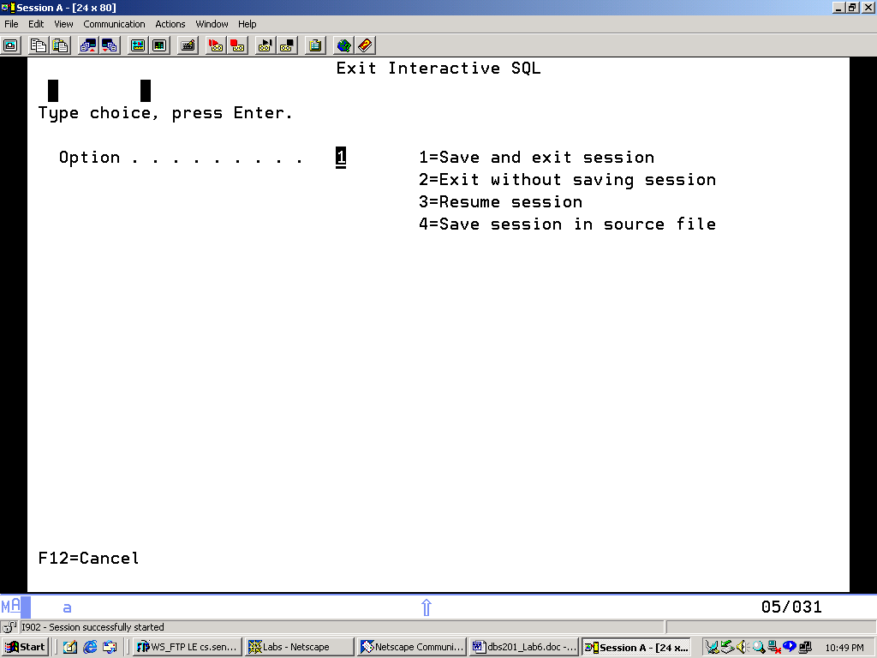<![endif]><span style="mso-spacerun: yes"></span>

You will use the default option 1. **<span style="mso-spacerun: yes"></span>Do not** ever use option 2 when at this screen.<span style="mso-spacerun: yes"></span>

<![if !supportEmptyParas]><![endif]><o:p></o:p><span style='text-decoration:none;text-underline:none'>Press Enter.<o:p></o:p></span>

<div class="MsoNormal"><![if !supportEmptyParas]><![endif]><o:p></o:p></div><div class="MsoNormal">To sign off the system enter **signoff** at the command line.</div> <div class="MsoNormal"><![if !supportEmptyParas]><![endif]><o:p></o:p></div> **Type ==> SIGNOFF**<o:p></o:p>

<![if !supportEmptyParas]><![endif]><o:p></o:p>**21.**     You may close the emulator window and return to the ISeries Navigator window.  You will recall that you may find your printer output using Basic Operations.  Find your printouts and print them as you did in Lab 1.  Now go pick up your printouts. <div class="MsoNormal"></div>  <div class="MsoNormal"></div>

**<span style='font-size:14.0pt;mso-bidi-font-size:12.0pt'>LAB SUMMARY:<o:p></o:p></span>**

<div class="MsoNormal"></div>

1. Sign on with USER and PASSWORD – use the **Tab** key and then the **Enter** key.
2. <div class="MsoNormal" style="margin-left:.25in">To use Page up, Page down and arrow keys, **the Scroll Lock key must be off**.
3. The **Reset** key is mapped to ESC or Left CTRL.
4. </div> <div class="MsoNormal">Useful function keys:

|  |  |
| --- | --- |
| F4 | Prompting key – you can even prompt a parameter on a prompted command |
| **F13** | Allows you to change SQL session attributes – redirect output, SQL naming etc |
| **F9** | Retrieves the previous command.<span style="mso-spacerun: yes"> </span>In SQL you can Page up, place the cursor on a command and press F9 to retrieve it. |
| **F1** | Help key - can be used on messages and on parameters for additional help |
| **F10** | Can be used to look at the job log.<span style="mso-spacerun: yes"> </span>If one message does not solve your problem, a different message in the job log may help. |
| **F3** | Exit key. |
| **F12** | Cancel key. |

1. **STRSQL** is used to initiate interactive SQL from a menu screen
2. Log off the system - type **SIGNOFF**</div>

**Lab 10 Submission NAME:**

1) Using the set of 3NF relations from Part A of Lab 6 shown below:

CUSTOMER [ CustNo, CustName, CustStreet, CustCity, CustSt, CustZip, RepNo ]

PART [ PartNo, PartDescr, QtyOnHand, Class, Whse, Price]

ORDER [OrderNo, OrderDate, CustNo ]

ORDERDetail [OrderNo, PartNo, NumOrdered ]

REP [RepNo, RepName]

Merge the following set of relations obtained from 2 additional user views into the above set of 3NF relations and write complete list of 3NF Relations.

REPLIST [ RepNo, RepName, Address, PhoneNo, RegionNo ]

REPLISTCUST [ RepNo, CustNo, SalesTargetAmount ]

CUST [ CustNo, CustName, Email, Phone]

REPSUMM [ RepNum, RepName, RegionName ]

2) Write your name on the printouts you were asked to create for Lab 10 Part B.

<span style='font-size:14.0pt;mso-bidi-font-size:12.0pt'><![if !supportEmptyParas]><![endif]><o:p></o:p></span>

</div>